Things to do in Edinburgh near NDAS 2022
Ailbhe’s favourites

Van Gogh Alive multisensory exhibition
£23 (£21 for students) but worth it. Book soon as tickets selling fast
https://vangoghaliveuk.com/edinburgh/

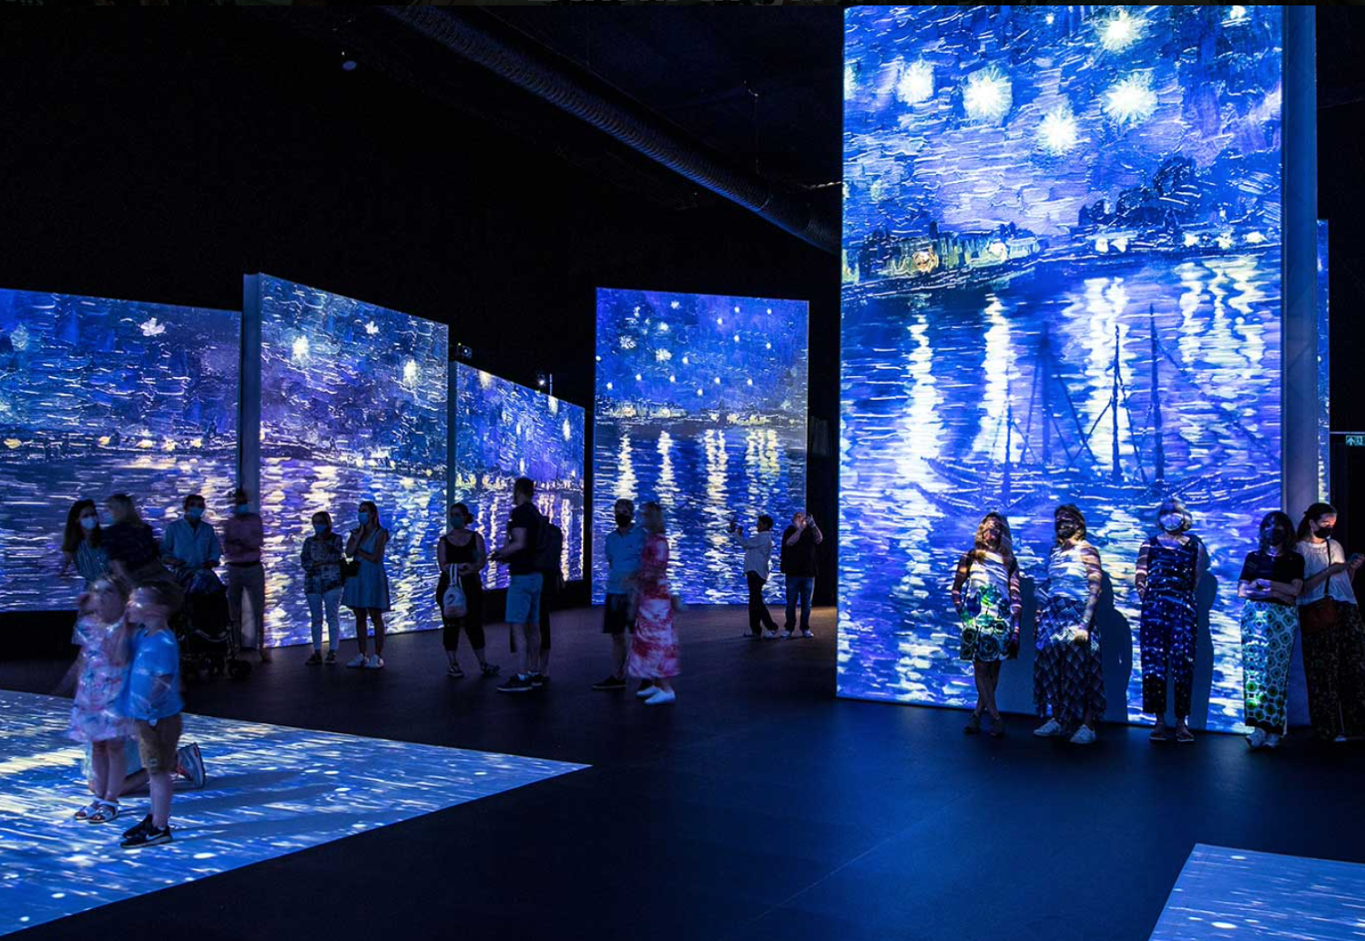

Walk from the Castle to the Palace
There is one mile between Edinburgh Castle and Holyrood Palace (sometimes called Palace of HolyroodHouse), this road is called the Royal Mile. You get a great view of Edinburgh from the Castle and an amazing view of the Salisbury Crags and Holyrood Park from the Palace. Also, the Royal Mile has lovely restaurants, cafes, and tourist shops. In my opinion, this short walk is the best way to get a good sense of Edinburgh.

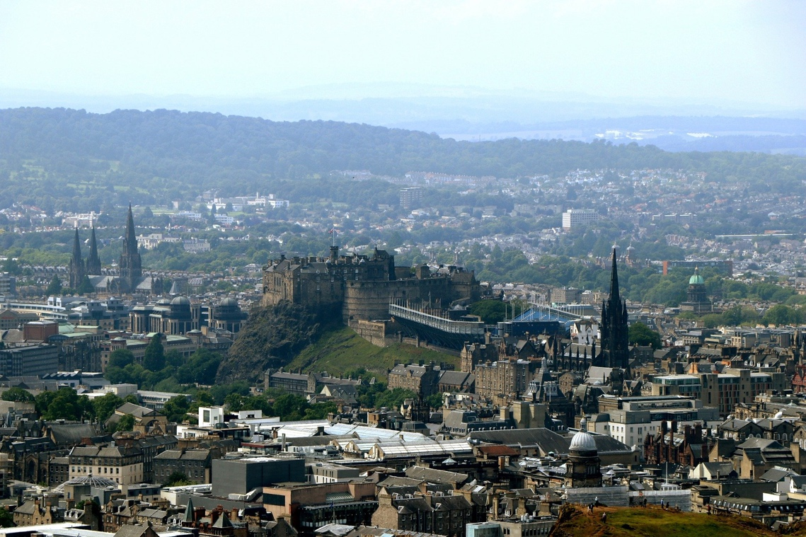

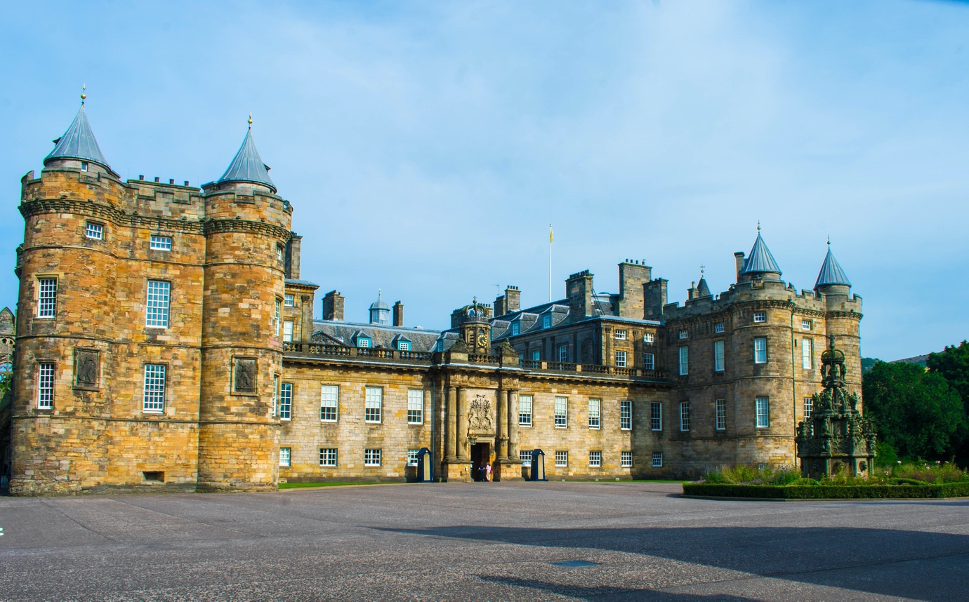

Harry Potter Fans:
Go to Victoria Street, famous for being what JK Rowling thought of when imagining Diagon Alley, and find the Harry Potter shops

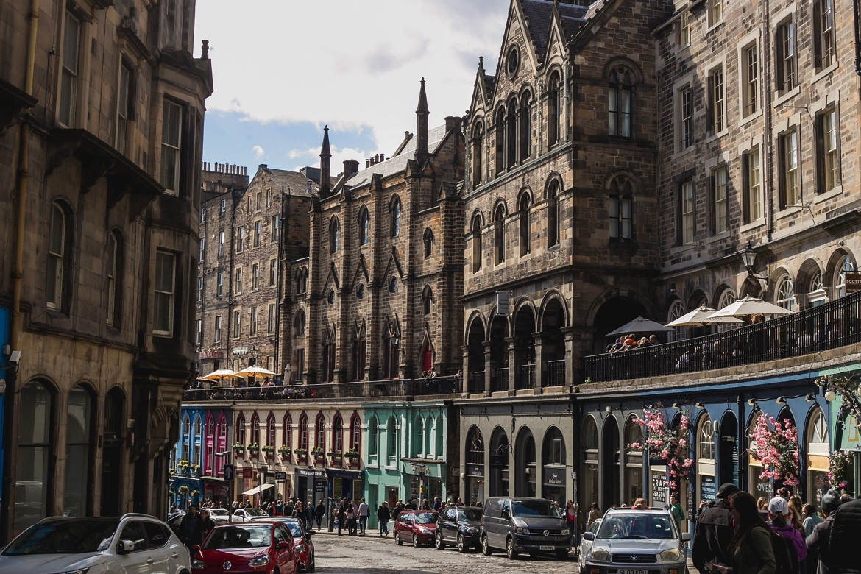

If you want to see the University of Edinburgh:
The University of Edinburgh has several campuses scattered in and around the city. One of the prettiest is the Old College (also called the University of Edinburgh School of Law). You could also walk around the corner to Bistro Square where the student union is and the McEwan Hall.
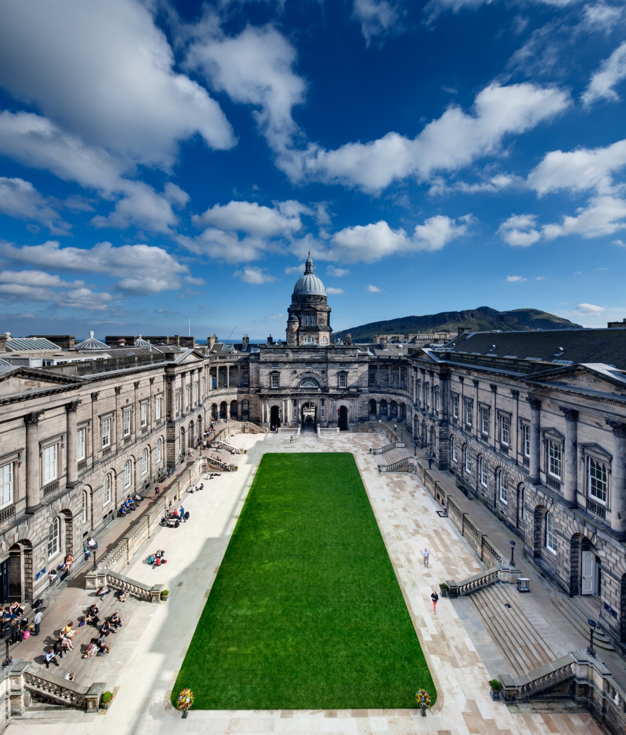

Nature:
There are several hilly walks in Edinburgh. Most people will say to go up Arthur’s seat. If you wanted a shorter walk, and closer to the NDAS location, my favourite walk is up the Salisbury Crags. Start at Holyrood Palace.

You could also get the bus/taxi to Portobello beach in Leith.
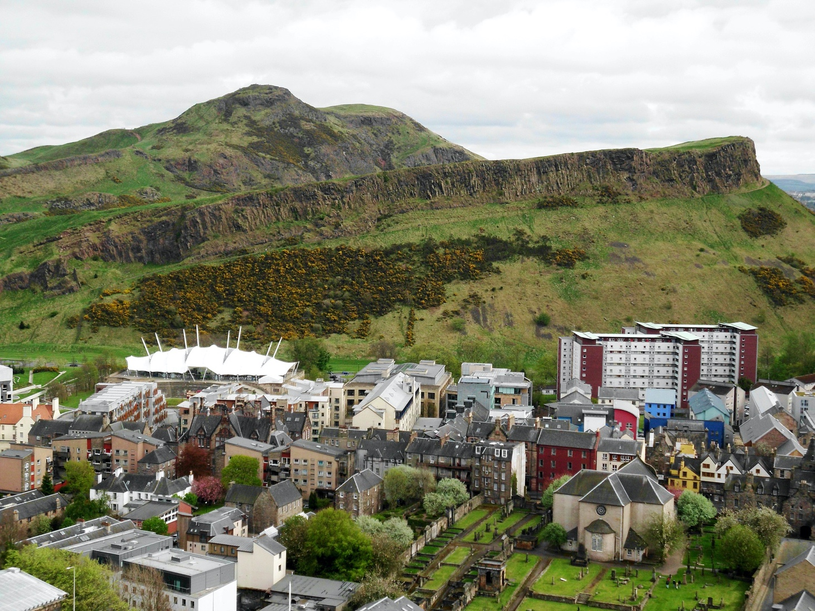

Galleries and Museum:
National Museum of Scotland
Scottish National Gallery
Scottish National Gallery of Modern Art visit

They are all free!

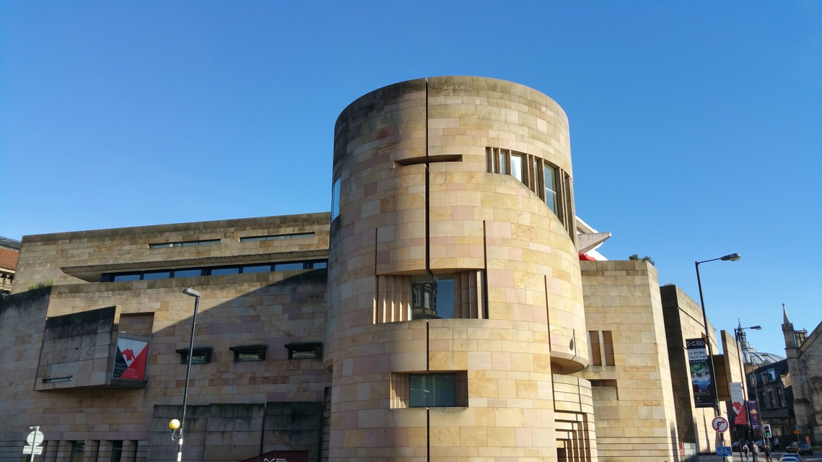

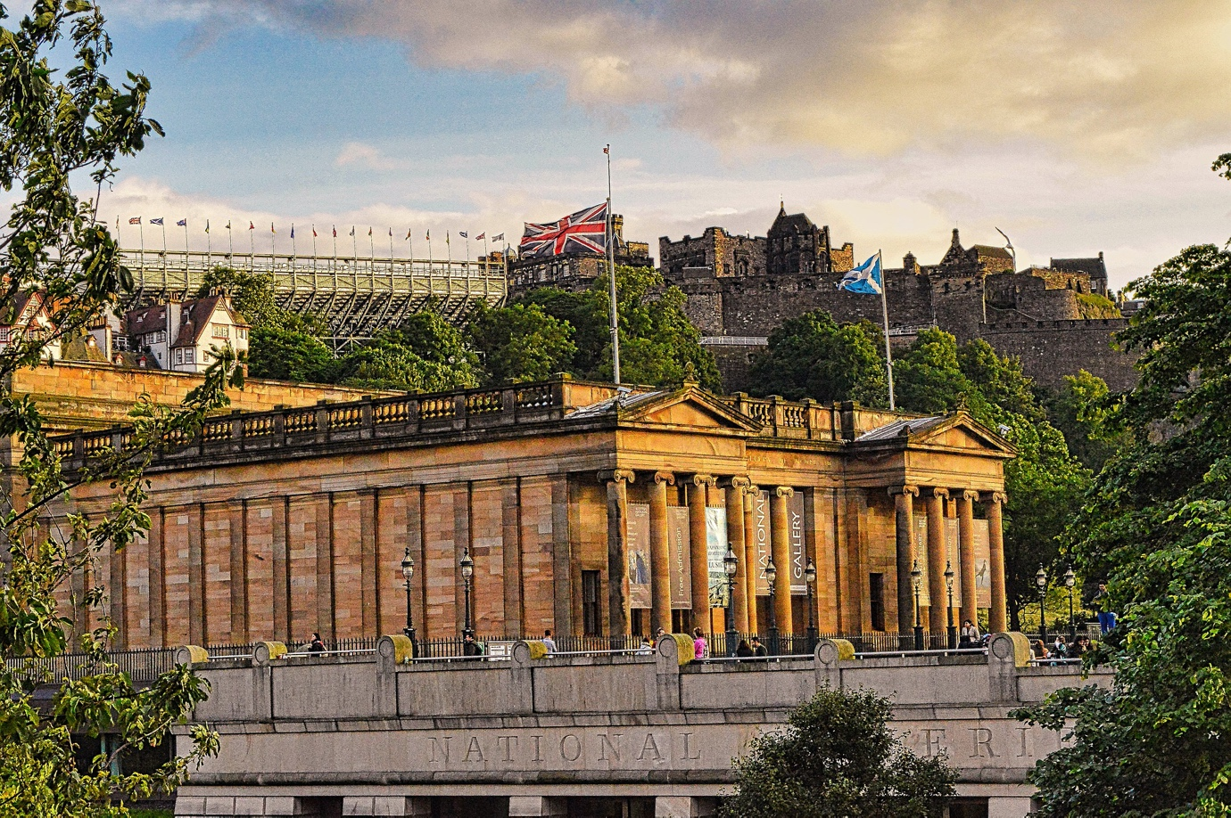

Restaurants:
Ting Thai (thai food)
Mariachi Restaurant (Mexican food)
TREACLE (Indian food)
Petit Paris (french food)
Thomas J Walls (brunch food)
Nile Wraps (lunch time cheap option)
Yamato (sushi)
La Locanda Edinburgh (Italian food)
Civerinos Slice on Forrest Road (Pizza)
Marys Milk Bar (ice cream)
Umai Sushi and Ramen Kitchen (Japanese food)
Cadiz (seafood)
Mimi’s little bakehouse on Market Street (brunch food)
The Dome (fancy – brunch, dinner, or drinks)
Mother India (Indian food)
Chez Jules, Hanover Street (French food)

Pubs and bars:
The Holyrood 9A (right beside the Outreach centre if looking for somewhere convenient)
Albanach
The Pear Tree (student kind of place)
Subway Cowgate (student kind of place)
The Garden at Teviot (student union)
Doctors
56 North
Boteco Do Brasil
O'Oliviero Edinburgh (also good for food)
Voodoo rooms
Johnnie Walker Princes Street Rooftop Bar
The Brewhemia Edinburgh
Tolbooth Tavern
The White Hart Inn
The Black Cat Edinburgh
The Three Sisters
Bannerman’s Bar
The Last Drop
Frankenstein
Whistle Binkies

For anyone staying in Leith
Teuchters Landing (food and drink)
Hemingway’s (food and drink)

