NDAS22 Edinburgh accommodation Options

Email Ailbhe if you have questions about accommodation, travel, or the city a.m.mckinney@sms.ed.ac.uk

Please book as soon as possible as the Royal Highlands Show is also being held in Edinburgh the week of the conference.

If you want to stay in a dormitory in a hostel or an airbnb, but would rather stay with people going to NDAS22, email Ailbhe to put you in touch with each other by this date: 13.05.2022

NDAS 2022 will be held in the Outreach Centre on Holyrood road.
Address: Outreach Centre 9C Holyrood Rd, Edinburgh EH8 8FP

It looks like this from the front:

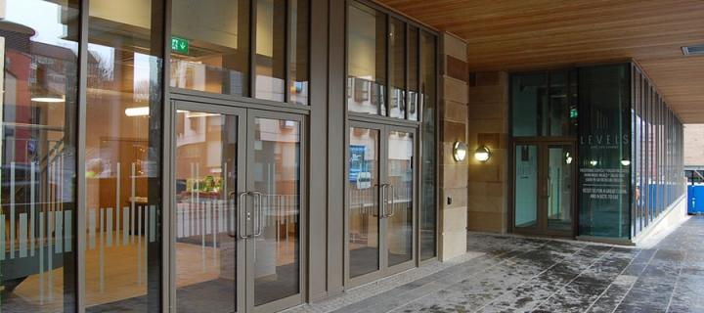

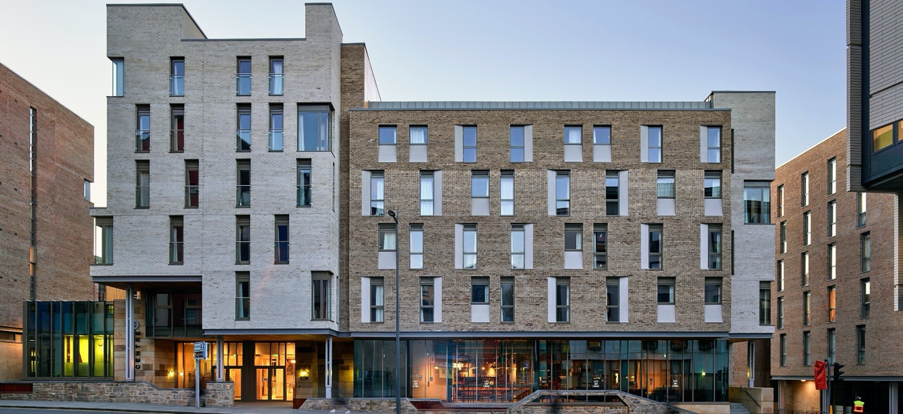

Accommodation Options:

Prices below are for one night.
Please note there are also many Airbnbs in the city centre (private and shared) starting from £50

Ten minutes or less walk to Outreach centre

St Christopher's Edinburgh Old Town £20
32 Market St, Edinburgh, Old Town, Edinburgh, EH1 1QB, United Kingdom
(Dormitory)

CoDE Pod – The CoURT – Edinburgh £25
1a Parliament Square, Old Town, Edinburgh, EH1 1RF
(Dormitory)

Kick Ass Grassmarket £25
2 West Port, Old Town, Edinburgh, EH1 2JA, United Kingdom
(Dormitory)

TravelLodge Edinburgh Central £144
33 St. Mary's Street, Edinburgh

Edinburgh City Centre Royal Mile hotel Premier Inn £168
33 East Market Street, Old Town, Edinburgh
EH8 8FR

Hub by Premier Inn Edinburgh Royal Mile hotel £122
37 East Market Street, Edinburgh,
EH8 8FR

Holiday Inn Express Edinburgh - Royal Mile £240
300 Cowgate, Edinburgh

A little further, 20 minute walk or less

Destiny Student - Holyrood (Brae House) £42
31 Abbeyhill, Old Town, Edinburgh, EH8 8EL, United Kingdom

Pollock Halls - Edinburgh First - Campus Accommodation £34
18 Holyrood Park Road, Edinburgh, EH16 5AY, United Kingdom

Edinburgh Backpackers £65
65 Cockburn Street, Old Town, Edinburgh, EH1 1BU, United Kingdom

Edinburgh Holiday Guest House £65
7 Minto Street, Edinburgh, EH9 1RG, United Kingdom

Castle Rock Hostel £70
15 Johnston Terrace, Edinburgh, EH1 2PW, Scotland, United Kingdom

Edinburgh Central Youth Hostel £102 (shared rooms for cheaper)
9 Haddington Place, Edinburgh, Mid Lothian

Hub by Premier Inn Edinburgh City Centre (Rose Street) £125
Rose Street, South Lane, EdinburghEH2 2NN

Leonardo Hotel Edinburgh City £170
79 Lauriston Place Edinburgh

Travelodge Edinburgh Central Waterloo Place £182
17 Waterloo Place, Edinburgh

Travelodge Edinburgh Central Rose Street £198
37-43 Rose Street, Edinburgh

Travelodge Edinburgh Central Queen Street £198
30-31 Queen Street, Edinburgh

Holiday Inn Express: Edinburgh City Centre £214
Picardy Place, Edinburgh

Would probably need to get an uber or taxi in the morning: less than 15 minutes’ drive

Rockville Hotel (beachfront) £63
2 Joppa Pans, Portobello, Edinburgh, EH15 2HF, United Kingdom –

Argyle Backpackers £50
14 Argyle Place, Edinburgh, EH9 1JL, Scotland, United Kingdom

OYO Arden Guest House. £82
126 Old Dalkeith Road, Edinburgh, EH16 4SD, Scotland, United Kingdom

Ascot Guest House £60
98 Dalkeith Road Edinburgh

International Guest House £75
37 Mayfield Gardens, Newington, Edinburgh

Edinburgh37 £120
37 Mayfield Gardens, Edinburgh, EH9 2BX, Scotland, United Kingdom

Travelodge Edinburgh Cameron Toll £113
43 Craigmillar Park,, Cameron Toll,

Edinburgh East hotel Premier Inn £130
228 Willowbrae Road, Edinburgh

Edinburgh Leith Waterfront hotel Premier Inn £155
51-53 Newhaven Place, Leith, Edinburgh EH6 4TXel Edin

Leonardo Royal Hotel Edinburgh Haymarket £170
1 Morrison Link Edinburgh

Holiday Inn Express Edinburgh - Leith Waterfront £170
Britannia Way Ocean Drive Leith, Edinburgh

